1. **Create form of type input text, email, password, radio button text Area, drop down and navigate to success page and display files of form in table (CSS, HTML).**

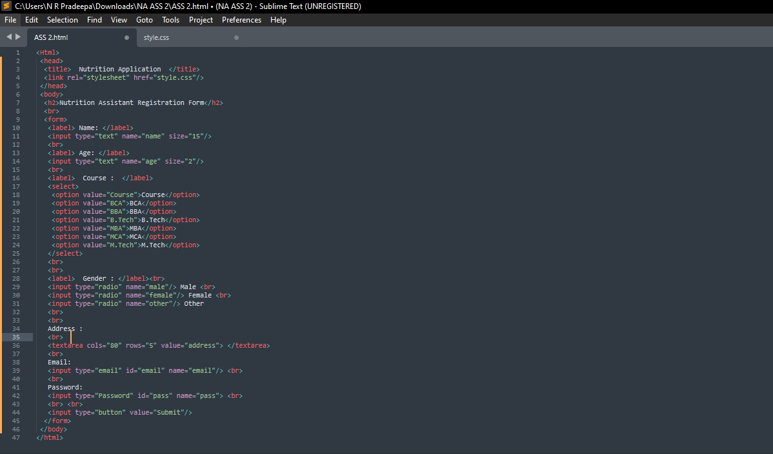

**2.For CSS create external style sheet for above task (separate CSS file and link that in html).**

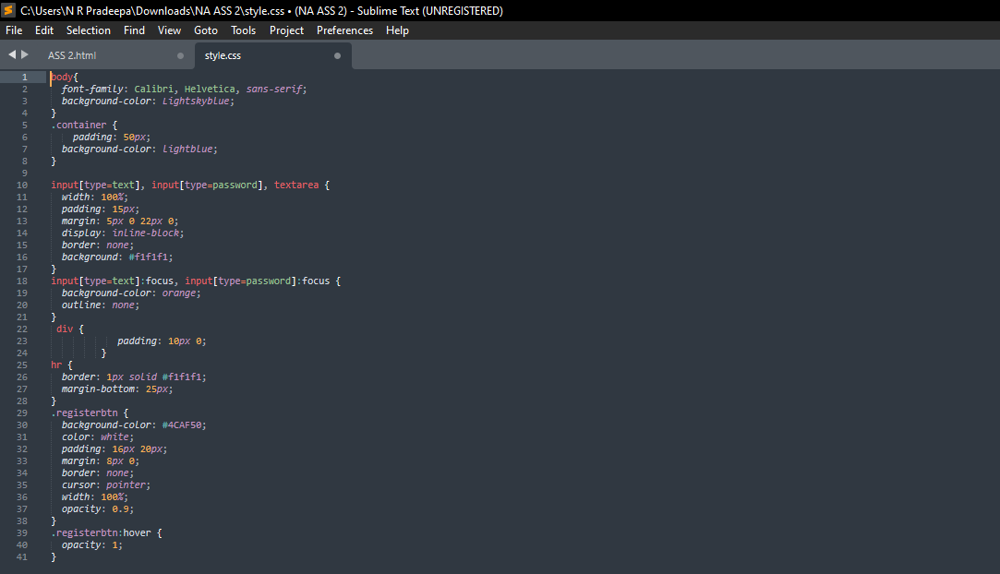

**OUTPUT:**

